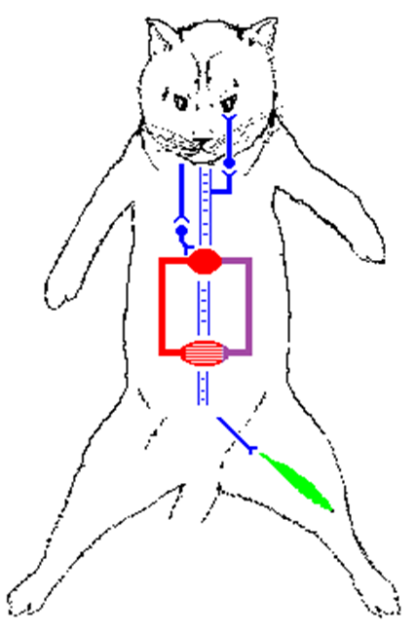

**Chart Recorder**

**Femoral Vein  
Drug Injection**

**Stimulator**

**Femoral   
Artery   
Canulla**

**Tibialis Anterior  
Muscle**

**Sciatic Nerve**

**Vagus   
Nerve**

**BP  
HR  
NM  
SK**

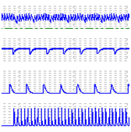

**Superior Cervical Ganglion**

**Nictitating  
Membrane**

**Heart**